**ANEXO**

**ANÁLISIS DE VIENTO PARA VIVIENDAS**

**PROTOTIPO DUPLEX**

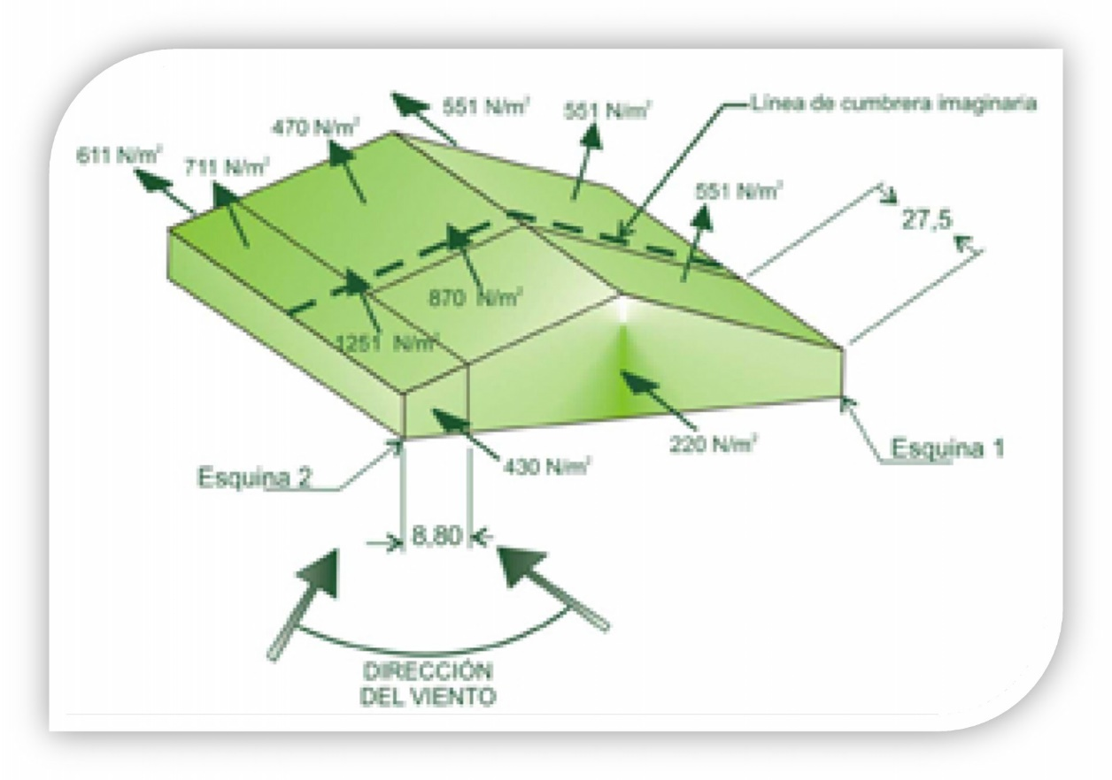

**NORMATIVA INTI – CIRSOC 102 – 2005**

**RESISTENCIA – CHACO**

|  |  |  |  |  |  |  |  |
| --- | --- | --- | --- | --- | --- | --- | --- |
| **ANÁLISIS DE VIENTO** | | | | | | | |
| **SPRFV - CUBIERTA** | | | | | | | |
| **CIRSOC 102 - 2005 - FIGURA 3** | | | | | | | |
|  |  |  |  |  |  | |
| **Carasteristicas Generales** | |  |  |  |  | |
| Tipo de Exposición | B |  |  |  |  | |
| Categoría | II |  |  |  |  | |
| Factor de importancia (I) | 1.00 |  |  |  |  | |
| Velocidad Básica | 45.00 | N/m² |  |  |  | |
| Lado Mayor | 15.20 | m |  |  |  | |
| Lado Menor | 7.62 | m |  |  |  | |
| Altura media de Cumbrera | 6.00 | m |  |  |  | |
|  |  |  |  |  |  | |
| **PRESIÓN DINÁMICA** | | | | | | | |
|  | |  | | --- | |  | |  |  |  |  | |
|  |  |  |  |  |  | |
|  |  |  |  |  |  | |
| **Kzt - Factor de terreno** | | Terreno Plano | **1.00** |  |  | |
| **Kd - Factor de direccionalidad del viento** | | Edificio | **0.85** |  |  | |
| **Kz - Coeficiente de exposición** | | |  |  |  | |
| Denominación | Altura | Exposición |  |  |  | |
| [m] | B |  |  |  | |
| Altura media - h | 6.00 | **0.62** |  |  |  | |
|  |  |  |  |  |  | |
| **PRESIÓN DINÁMICA** | **654.18** | **N/m²** | **→** | **qh** |  | |
|  |  |  |  |  |  | |
|  |  |  |  |  |  | |
| **PRESIONES DE VIENTO DE DISEÑO - SPRFV** | | | | | | | |
|  | $$p=q x G x Cp -qi x (GCpi)$$ |  |  |  |  | |
|  |  | | | |  |
|  |  |
|  |  |  |  |  |  | |
| **FACTOR DE RAFAGA - G** | | | | | | | |
|  |  |  |  |  |  | |
| **Altura media h** | **Ancho menor** | **h/ancho menor** | **Estructura** | **G** |  | |
| **[m]** | **[m]** |  | |
| 6.00 | 7.62 | 0.79 | Rígida | 0.85 |  | |
|  |  |  |  |  |  | |
|  |  |  |  |  |  | |
| **COEFICIENTE DE PRESION EXTERNA (Cp) p/Cubierta - VIENTO PERPENDICULAR A CUMBRERA** | | | | | | | |
|  |  |  |  |  |  | |
| **Superficie** | **h/L** | **Angulo - Cp** |  |  |  | |
| **6** |  |  |  | |
| A barlovento | 0.39 | -0.70 |  |  |  | |
| A sotavento | -0.30 |  |  |  | |
|  |  |  |  |  |  | |
| **COEFICIENTE DE PRESION EXTERNA (Cp) p/Cubierta - VIENTO PARALELO A CUMBRERA** | | | | | | | |
|  |  |  |  |  |  | |
| **Superficie** | **h/L** | **Distancia horizontal desde el borde a barlovento** | | | **Cp** |
|  | | |
| Cubierta | 0.79 | 0 - h/2 | | | -1.04 |  | | |
| ≥ 2h | | | -0.70 |  | | |
|  |  |  |  |  |  | |  | | |
| **COEFICIENTE DE PRESION INTERNA - (Gcpi)** | | | | | | | |  | | |
|  |  |  |  |  |  | |  | | |
| **Clasificación de Cerramiento** | **+GCpi** | **-GCpi** |  |  |  | |  | | |
| Edificio Cerrado | 0.18 | -0.18 |  |  |  | |  | | |
|  |  |  |  |  |  | |  | | |
| **PRESIONES DE DISEÑO SOBRE EL SPRFV - VIENTO PERPENDICULAR A LA CUMBRERA** | | | | | | | |  | | |
|  |  |  |  |  |  | |  | | |
| **Superficie** | **z [m]** | **q [N/m2]** | **Cp** | **Presión Neta [N/m2]** | | | |  | | |
| **Gcpi+** | **Gcpi-** | |  | | |
| Cubierta a Barlovento |  | 654.18 | -0.70 | -506.99 | -271.48 | |  | | |
| Cubierta a Sotavento |  | 654.18 | -0.30 | -284.57 | -49.06 | |  | | |
|  |  |  |  |  |  | |  | | |
| **PRESIONES DE DISEÑO SOBRE EL SPRFV - VIENTO PARALELO A LA CUMBRERA** | | | | | | | |  | | |
|  |  |  |  |  |  | |  | | |
| **Superficie** | **z [m]** | **q [N/m2]** | **Cp** | **Presión Neta [N/m2]** | | | |  | | |
| **Gcpi+** | **Gcpi-** | |  | | |
| Cubierta | 0 - h/2 | 654.18 | -1.04 | **-696.05** | -460.54 | |  | | |
| ≥ 2h | 654.18 | -0.70 | -506.99 | -271.48 | |  | | |

Según lo analizado, la presión neta máxima de succión en cubierta es de

$$W = -696,05 N/m²$$